Controlling Stack Emissions in the Wood Products Industry & Wood Fired Boilers

Gerry Graham
Chief Engineer - PPC Industries, Longview, TX

INTRODUCTION
Electrostatic precipitation has been a reliable technology since the early 1900's. Originally developed to abate serious smoke nuisances, the manufacturers of zinc, copper, and lead quickly found electric gas cleaning a cost efficient way to recover valuable product carried out of the stacks from furnace operations. Today electrostatic precipitators are found mainly on large power plants, cement plants, incinerators, and various boiler application.

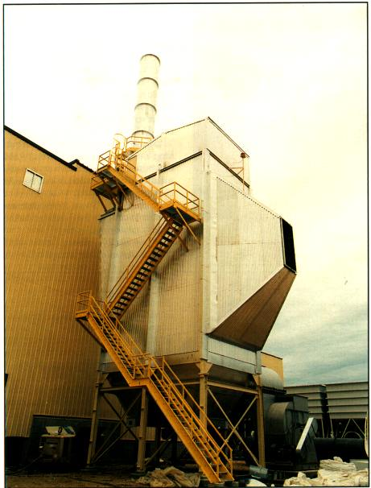
In the wood products industry, the dry electrostatic precipitator preceded by multi clones is now normally considered the best available control technology for wood fired boiler emissions. Wet electrostatic precipitators have found renewed interest from OSB, particle board, and plywood veneer manufactures for controlling dryer exhaust.

DESIGN AND OPERATION
A precipitator is a relatively simple device. The main components are as follows:
- An insulated and lagged shell
- Collection plates or tubes
- Discharge electrodes
- Collection Plate Rappers/Electrode Vibrators
- Hoppers

Dust laden gases are pushed or pulled through the box with the assistance of a fan. The air flow is channeled into lanes formed by the collection plates or tubes. Discharge electrodes are centered between each collection plate/tube to provide a negative charge to the surrounding dust particles. The collection plates/tubes are positively grounded and act as a magnet for the negatively charged dust particles. The collected dust is transported down the collection plates and electrode with the assistance of a rapper or vibrator system into the collection hopper.
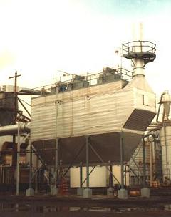
An electrostatic precipitator can consistently provide 99%+ removal reducing emissions levels to 0.002 - 0.015 grains per dry standard cubic foot of exhaust gas.
Precipitators are designed to handle gas flow form 10,000 cfm to 300,000 cfm and can operate at temperatures as high as 750 degrees F. Normal gas flow through a precipitator is 2-5 feet per second, consequently, the pressure drip is only 0.5" wc. When replacing existing scrubber systems the fan horsepower to operated the precipitator can usually be decreased to one fourth of the scrubber system, which may have a pressure drop as high as 20" in order to deliver comparable efficiencies.
Insulated Steel Housing: The development of modular, factory built units has significantly lowered the installed cost of precipitators. Dry precipitators are normally fabricated from 3/16" thick steel plate, insulated and lagged with aluminum. The electrodes are made of steel tubing and the collection plates are made of rolled steel. Since no moving parts are in contact with the gas stream, the housing can last 15-20 years. Wet precipitators are traditionally fabricated of stainless steel for corrosion resistance.
Discharge Electrodes: The advancement of the discharge electrode has solved many of the maintenance complaints associated with precipitators in the past. Originally, the dust particles were charged by a series of small diameter wires which were suspended from a ceiling rack and weighted at the bottom. This maze of electrodes was subject to electric erosion. Replacement was slow, cumbersome and required the unit to be off-line.
Today, discharge electrodes are rigid and constructed of 2" steel tubing, securely fastened to the upper rack and guided at the bottom. Ten years of continuous service is the expected norm.
Rappers and Vibrators: Heavy duty rappers are used by PPC in the wood industry. They consist of 30 pound piston hammers designed to rap small sections of collection plates. A timer periodically releases the rapper to transfer the dust on the collection plates to the hopper.
Electric vibrators are placed on the electrode rack to transfer any collected dust to the hopper and are operated by a timer.
Power: A typical precipitator will take 480 volt AC and with he assistance of transformer/rectifier converts the power to operated the discharge electrode's at 55-70 kv DC. This leads most inquirers to conclude they are huge electricity consumers. In reality, the electrostatic precipitator is the lower power consumer available to accomplish the job. Electrostatic forces are applied directly to the particles and not the entire gas stream. Combining this feature with the low pressure drop (0.5" wc) across the system results in power requirements approximately 50% of comparable wet systems and 25% of equivalent bag filter systems.

Power Consumption Chart
ACFM | KW | Hourly Operating Cost
20,000 | 10 | $0.50
50,000 | 21 | $1.05
120,000 | 62 | $3.10

COMPETING TECHNOLOGIES
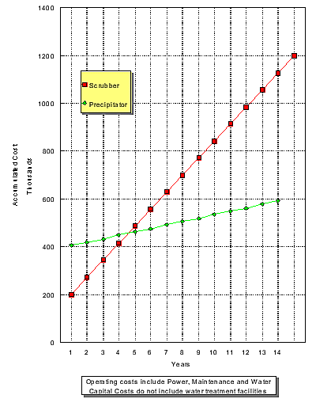
A dry electrostatic precipitator operates at temperatures above 700ºF and maintains the fly ash in its natural dry condition simplifying material handling.
Wet Scrubbers: A scrubber saturates the gas stream in order to remove the dry fly ash. The wet ash has to separate from the water in settling ponds or through a de-sludging unit which increases the annual labor and operating cost.
It is not uncommon to see 150 to 300 hp fans on scrubber installations in the wood industry. The energy necessary to separate the particulate from the gas stream can require 15" - 20" wc of pressure drop through a typical venturi. These are huge and wasteful power consumers, increasing the plant's overall operating cost.
Wet scrubbers have to contend with freezing in northern climates and equipment corrosion. Finally, regulatory authorities are moving towards zero water discharge from operating plants.
Baghouses: The high temperatures and periodic cinders from the plant boiler can cause fire problems with baghouses. Periodic bag replacement is a definite operating cast consideration which affects the overall cost of a baghouse installation.

NEW APPLICATIONS
Dryers: OSHA and state regulatory authorities are beginning to look at dryer emissions. There is an inside emission problem because the fly ash accumulates on top of the veneer. There is also an external emission problem from the dryer vent stack.
A dry precipitator can be installed after the burner blend chamber to remove the fly ash. The recirculation of the dryer air stream is then cleansed of incoming ash. This arrangement produces cleaner veneer and eliminates dryer vent emissions.
Wet Units: Wet electrostatic precipitators have seen renewed interest in the wood products industry as OSB, particle board, and veneer plants are required to control VOC emissions form their dryer exhaust. The wet est serves to remove particulate emissions and "condensible" VOC's (pinenes, terpenes, cymene, toluene, etc.) from their dryer exhaust. Depending upon the exhaust temperature and partial pressure considerations of each component, the wet esp can reduce the VOC emission by 20 - 40% while solving all opacity problems. If additional VOC removal efficiencies are required, the wet precipitator may be a necessary pre-treatment item for incinerators or biofiltration systems which do not handle particulate concentrations very well.
The purpose for the "wet" electrostatic system is to mainly prevent fires. The particulate carry over form an OSB dryer can represent large fiber stands which can be ignited by the sparking inside a dry precipitator setting off a hopper fire. The wet precipitators apply a water quench to the gas stream before entering the collecting tubes. The collection tubes are also continuously sprayed with water in order to wash the particulate off the tubes thereby eliminating any chance of combustion.
Pre-cleaner: Wet electrostatic precipitators are excellent particulate removal devices for use ahead of RCO's, TRO's, and Biofilters. These VOC removal devices are sensitive to particulate in the flue gas stream. Since wet electrostatic precipitators can provide emission levels as low as 0.003 gr/dscf, they prevent fouling of the VOC removal devices.
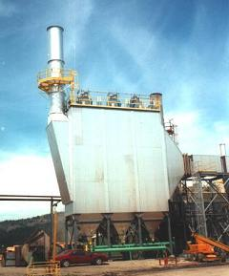
Thermal Oil Heater: Electrostatic precipitators are fast becoming the device of choice for controlling emissions from thermal oil heaters. Several of the recent Canadian OSB plants have selected PPC for the electrostatic precipitator to control the particulate from combustion of wood. The electrostatic precipitator's low power consumption combined with low maintenance make it an excellent choice for plants with a limited number of operating personnel. The boiler PLC can be configured with eh 10-12 channels required to completely automat the operation of the electrostatic precipitator. The PLC provides the plant with a written chart for submittal to the regulatory agencies that require continuous emissions monitoring.

CONCLUSION
Electric Gas Cleaning is an old proven technology for removing particulate emissions from exhaust stacks. Electrostatic precipitators have proven to be reliable workhorses in the wood products industry as more companies focus on profits.

